E-TrustEx 2.0
JMS Interfaces
October 2014

Table of Contents
Purpose 3
Data Structure 4
Authentication 7
Error and Response Handling 8
Inbound Interface 9
Outbound Interface 10
Annex 1 : Document WSDL 11

Purpose

The purpose of this document is to document the JMS interfaces of eTrustex platform.
We must distinguish the interface for inbound messages (messages arriving in eTrustex) and outbound messages (messages sent from eTrustex).
The first section will provide more information about the data structure to be used in both cases.
The second section will provide information about authentication (for inbound and outbound messages)
The third section will provide information about response and error handling.
The fourth section will provide information specific to inbound messages interface.
The fifth section will provide information specific to outbound messages interface.

Data Structure

JMS messages (inbound and outbound) will use the same XML structure based on SOAP envelope structure.
{ http://schemas.xmlsoap.org/soap/envelope/}:Envelope
{ http://schemas.xmlsoap.org/soap/envelope/}:Header
{ec:services:wsdl:Document-1}: Header
{ http://schemas.xmlsoap.org/soap/envelope/}:Body
{ec:services:wsdl:Document-1}:SubmitDocumentRequest
{ec:services:wsdl:Document-1}:transactionNamespace
<xsd:any />
Every message must have a header and a body.
A specific type "SubmitDocumentRequest" has been created. It can contain any well-formed XML.
The Header contains a Business header and a Technical header.
{ ec:schema:xsd:CommonAggregateComponents-2}:BusinessHeader
{http://www.unece.org/cefact/namespaces/StandardBusinessDocumentHeader}:Sender
{http://www.unece.org/cefact/namespaces/StandardBusinessDocumentHeader}:Receiver
{http://www.unece.org/cefact/namespaces/StandardBusinessDocumentHeader}:: DocumentIdentification
{http://www.unece.org/cefact/namespaces/StandardBusinessDocumentHeader}CreationDateAndTime
{ ec:schema:xsd:CommonAggregateComponents-2}:ValidationResult
{ ec:schema:xsd:CommonAggregateComponents-2}:TechnicalHeader
{urn:oasis:names:specification:ubl:schema:xsd:SignatureAggregateComponents-2}:SignatureInformation

The Business header contains Sender and Receiver parties information: as many as we have IDs (with different scheme identifier) for Sender and Receiver.
It also contains a field creationDateAndTime that contains the 'creation' date in eTrustex for outbound messages and the result of the Schematron validation.
The "transactionNamespace" element inside the SOAP body must be given in the form:
{<WSDL namespace>}<request local name>.
For example, for SubmitDocumentBundle, it should have the value:
{ec:services:wsdl:DocumentBundle-2}SubmitDocumentBundleRequest
SOAP over JMS protocol could be used for the implementation but the current document just formalizes the content of the messages.
An example of WSDL for Document 1.0 service is available in Error: Reference source not found.
The Technical header can contain signature information. This point will be discussed in the following section.
Here is an example of a request for SubmitDocumentBundle:

<soapenv:Envelope xmlns:soapenv="http://schemas.xmlsoap.org/soap/envelope/" xmlns:urn="urn:oasis:names:specification:ubl:schema:xsd:CommonAggregateComponents-2" xmlns:ec1="ec:schema:xsd:CommonAggregateComponents-2" xmlns:urn1="urn:oasis:names:specification:ubl:schema:xsd:CommonBasicComponents-2" xmlns:stan="http://www.unece.org/cefact/namespaces/StandardBusinessDocumentHeader" xmlns:sac="urn:oasis:names:specification:ubl:schema:xsd:SignatureAggregateComponents-2" xmlns:ec="ec:services:wsdl:DocumentBundle-2" xmlns:ec2="ec:services:wsdl:Document-1">
<soapenv:Header>
<ec:Header>
<ec1:BusinessHeader>
<stan:Sender>
<stan:Identifier>TRUSTSUPPARTY1</stan:Identifier>
</stan:Sender>
<stan:Receiver>
<stan:Identifier>TRUSTCUSTPARTY1</stan:Identifier>
</stan:Receiver>
</ec1:BusinessHeader>
</ec:Header>
</soapenv:Header>
<soapenv:Body>
<ec2:SubmitDocumentRequest>
<ec2:transactionNamespace>{ec:services:wsdl:DocumentBundle-2}SubmitDocumentBundleRequest</ec2:transactionNamespace>
<ec:DocumentBundle>
<urn1:ID>ID01_JMS</urn1:ID>
<urn1:IssueDate>2013-09-01</urn1:IssueDate>
<urn:SenderParty/>
<urn:ReceiverParty/>
<ec1:DocumentWrapperReference>
<urn1:ID>ID01</urn1:ID>
<urn1:DocumentTypeCode>BINARY</urn1:DocumentTypeCode>
</ec1:DocumentWrapperReference>
</ec:DocumentBundle>
</ec2:SubmitDocumentRequest>
</soapenv:Body>
</soapenv:Envelope>

Authentication

In order to authenticate the message issuer two mechanisms will be implemented:
-the use of a JMS header similar to the one used for HTTP basic authentication (http://tools.ietf.org/html/rfc2617).
JMS Header name: "Authorization"
JMS Header content: "Base64-encoded (userid ':' password)"
- XML enveloped signature (cf. http://www.w3.org/TR/xmldsig-core/ ) will be supported via inclusion in the Technical Header more precisely inside the Signature Information element.
This signature should cover the full soap envelope.

Messages sent by eTrustex will contain the authentication JMS header and will be signed with eTrustex's certificate.
Messages received by eTrustex will contain the authentication JMS header and will be optionally signed by the message issuer's certificate (i.e. the connected system's certificate). The support of electronic signature for incoming (to eTrustex) messages will be configurable in eTrustex.
In case only the Authentication JMS Header is used for incoming messages, we recommend using JMS over SSL to ensure a good level of security.

Error and Response Handling

The JMS interface will support request/response communication pattern thanks to a well know JMS headers: "JMSReplyTo ", "JMSMessageID" and "JMSCorrelationID".
More precisely, for inbound messages:
The message issuer will set a message ID in the JMSMessageID header and "reply queue" inside the JMSReplyTo header. The reply to queue is supposed to receive responses from eTrustex. In general a temporary queue will be used.
Etrustex will reply into that queue and it will copy the JMSMessageID of the request message into the JMSCorrelationID of the response message. This mechanism allows correlating requests and responses. In general a temporary queue is created to receive responses.
More information about temporary queues can be found for instance in:
http://www.onjava.com/pub/a/onjava/2007/04/10/designing-messaging-applications-with-temporary-queues.html
It is important to note that (this content comes from the previous reference):
- The life span of temporary destinations is only for the duration of the connection where they are created.
- When you close the connection that has a temporary destination, the destination is closed and its contents are lost.
This should not be a problem considering that JMS responses are equivalent to HTTP responses. The behaviour (and lifecycle) is very similar.
The system response for messages coming to the inbound interface is as follows:
1) Valid file -> -> sync ack on reply queue + RESPONSE_CODE 200
2) Not well formed XML -> RESPONSE_CODE 400
3) Unauth access -> RESPONSE_CODE 401
4) Async error (xsd issue) -> sync ack on reply queue + async APR
5) Unknown operation (e.g. SubmitDocumentXXXRequest) -> RESPONSE_CODE 500, SOAP Fault Undefined incoming message
6) Unknown document (e.g. DocumentBundleXXX) -> RESPONSE_CODE 500, SOAP Fault Undefined incoming message
7) Transaction namespace wrong -> RESPONSE_CODE 500, SOAP Fault Undefined incoming message
8) No Transaction namespace element -> RESPONSE_CODE 500, SOAP Fault Undefined incoming message.

Inbound Interface

The purpose of this interface is to receive messages into eTrustex.
The interface is similar to usual HTTP SOAP web services but JMS is used instead of HTTP.
The JMS queue to be used is "jms/documentQueue".
Nevertheless only one generic service is available (submit document). This is different from HTTP services that are strongly typed.

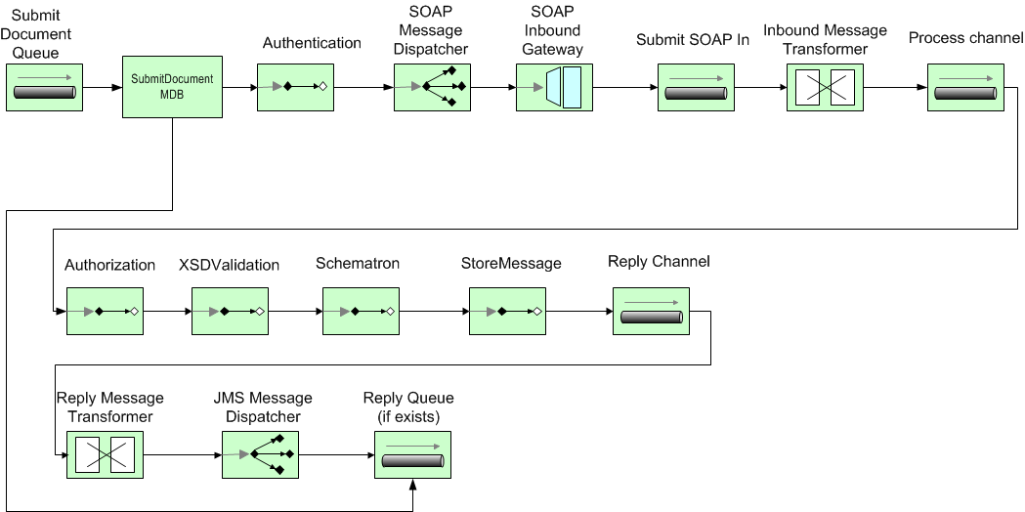Figure 1. JMS inbound interface and processing chain

Outbound Interface

The purpose of this interface is to route messages received in eTrustex to connected systems (e.g. European Commission Back-Office like CUBE for eProcurement pre-awarding.
One message can be routed to several endpoints. These endpoints can be HTTP or JMS endpoint.
In this particular case JMS endpoints must be configured in eTrustex in order to send received messages to connected systems.
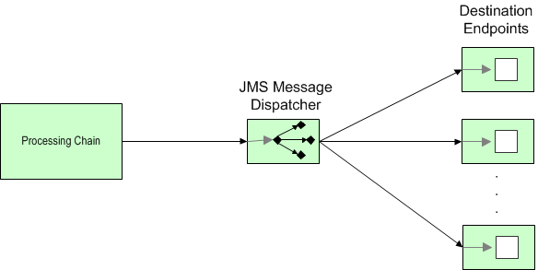
Figure 2. JMS Outbound interface

Annex 1 : Document WSDL

<?xml version="1.0" encoding="UTF-8"?>
<WL5G3N0:definitions name="Document" targetNamespace="ec:services:wsdl:Document-1" xmlns:WL5G3N0="http://schemas.xmlsoap.org/wsdl/" xmlns:WL5G3N1="ec:services:wsdl:Document-1" xmlns:WL5G3N2="http://schemas.xmlsoap.org/wsdl/soap/">
<WL5G3N0:types>
<xsd:schema elementFormDefault="qualified" targetNamespace="ec:services:wsdl:Document-1" xmlns:ack="ec:schema:xsd:Ack-2" xmlns:eccac="ec:schema:xsd:CommonAggregateComponents-2" xmlns:fault="urn:oasis:names:specification:ubl:schema:xsd:Fault-1" xmlns:soap="http://schemas.xmlsoap.org/wsdl/soap/" xmlns:tns="ec:services:wsdl:Document-1" xmlns:wsdl="http://schemas.xmlsoap.org/wsdl/" xmlns:xsd="http://www.w3.org/2001/XMLSchema">
<xsd:import namespace="ec:schema:xsd:Ack-2" schemaLocation="EC-Ack-2.0.xsd"/>
<xsd:import namespace="ec:schema:xsd:CommonAggregateComponents-2" schemaLocation="EC-CommonAggregateComponents-2.0.xsd"/>
<xsd:import namespace="urn:oasis:names:specification:ubl:schema:xsd:Fault-1" schemaLocation="EC-Fault-1.0.xsd"/>
<xsd:element name="SubmitDocumentRequest">
<xsd:complexType>
<xsd:sequence>
<xsd:element name="transactionNamespace"
type="xs:string" maxOccurs="1" minOccurs="1"/>
<xsd:any maxOccurs="1" minOccurs="1"/>
</xsd:sequence>
</xsd:complexType>
</xsd:element>
<xsd:element name="SubmitDocumentResponse">
<xsd:complexType>
<xsd:sequence>
<xsd:element name="Ack" type="ack:AcknowledgmentType"/>
</xsd:sequence>
</xsd:complexType>
</xsd:element>
<xsd:element name="Header" type="eccac:HeaderType"/>
<xsd:element name="Fault" type="fault:FaultType"/>
</xsd:schema>
</WL5G3N0:types>
<WL5G3N0:message name="submitDocumentRequest">
<WL5G3N0:part element="WL5G3N1:SubmitDocumentRequest" name="SubmitDocumentRequest"/>
<WL5G3N0:part element="WL5G3N1:Header" name="Header"/>
</WL5G3N0:message>
<WL5G3N0:message name="submitDocumentResponse">
<WL5G3N0:part element="WL5G3N1:SubmitDocumentResponse" name="SubmitDocumentResponse"/>
<WL5G3N0:part element="WL5G3N1:Header" name="Header"/>
</WL5G3N0:message>
<WL5G3N0:message name="FaultResponse">
<WL5G3N0:part element="WL5G3N1:Fault" name="FaultResponse"/>
</WL5G3N0:message>
<WL5G3N0:portType name="documentPortType">
<WL5G3N0:operation name="submitDocument">
<WL5G3N0:input message="WL5G3N1:submitDocumentRequest"/>
<WL5G3N0:output message="WL5G3N1:submitDocumentResponse"/>
<WL5G3N0:fault message="WL5G3N1:FaultResponse" name="FaultResponse"/>
</WL5G3N0:operation>
</WL5G3N0:portType>
<WL5G3N0:binding name="documentBinding" type="WL5G3N1:documentPortType">
<WL5G3N2:binding style="document" transport="http://www.openuri.org/2002/04/soap/jms/"/>
<WL5G3N0:operation name="submitDocument">
<WL5G3N0:input>
<WL5G3N2:header message="WL5G3N1:submitDocumentRequest" part="Header" use="literal"/>
<WL5G3N2:body parts="SubmitDocumentRequest" use="literal"/>
</WL5G3N0:input>
<WL5G3N0:output>
<WL5G3N2:header message="WL5G3N1:submitDocumentResponse" part="Header" use="literal"/>
<WL5G3N2:body parts="SubmitDocumentResponse" use="literal"/>
</WL5G3N0:output>
<WL5G3N0:fault name="FaultResponse">
<WL5G3N2:fault name="FaultResponse" use="literal"/>
</WL5G3N0:fault>
</WL5G3N0:operation>
</WL5G3N0:binding>
<WL5G3N0:service name="documentBindingQSService">
<WL5G3N0:port binding="WL5G3N1:documentBinding" name="documentBindingQSPort">
<WL5G3N2:address location="jms://wltdig03.cc.cec.eu.int:2121/weblogic.jms.XAConnectionFactory/Document-1.0Request"/>
</WL5G3N0:port>
</WL5G3N0:service>
</WL5G3N0:definitions>

